**Assignment#3 (Friday Lab 4.00 -6.00 PM)**

Q1. Define a class **Customer** as described in class diagram below:

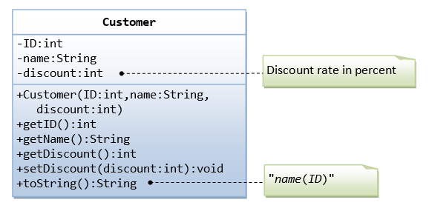

Q2. Use the above class Customer to design another class **Invoice** as described in class diagram below:

